Research Report on Broken Object Level Authorization (BOLA)

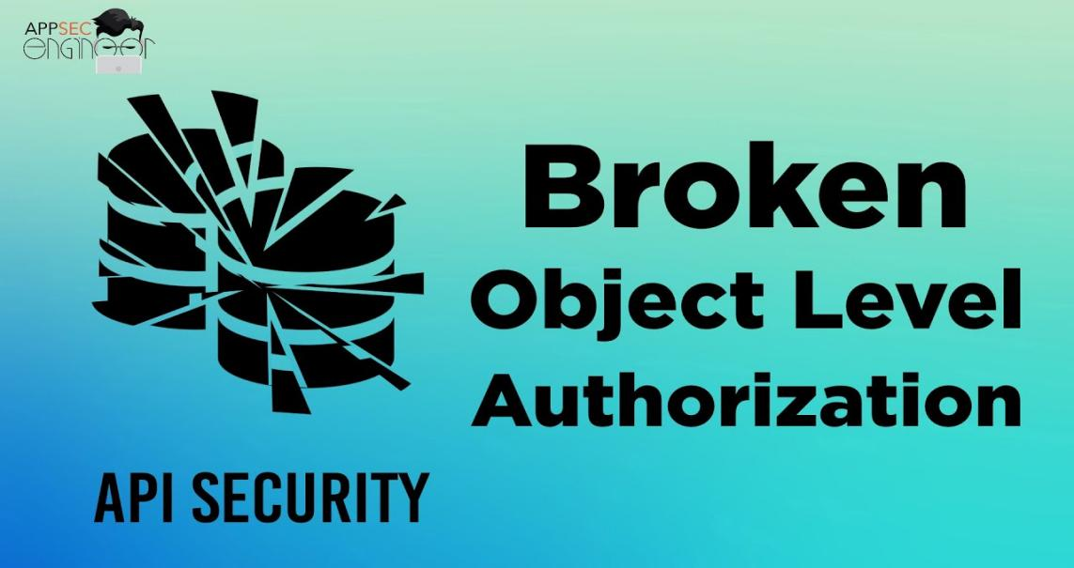

What is Authorization?
Authorization is the process of verifying whether a user has permission to access a specific resource or perform a particular action. It ensures that users can only interact with data or functionalities that align with their assigned permissions, protecting sensitive information and preventing unauthorized actions.

Key Components of Authorization:
- User Roles: Assigning roles such as admin, user, or guest to define access levels.
- Access Control Policies: Rules that dictate what actions or resources each role can access.
- Verification: Validating the user's permissions for each request.

What is Broken Object Level Authorization (BOLA)?
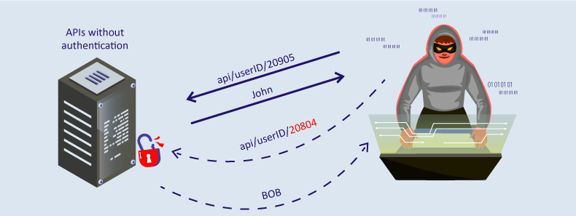
Broken Object Level Authorization (BOLA) is a critical security vulnerability that occurs when applications fail to enforce proper authorization checks at the object level. This allows attackers to manipulate object references and gain unauthorized access to sensitive data or functionality.

Example of BOLA:
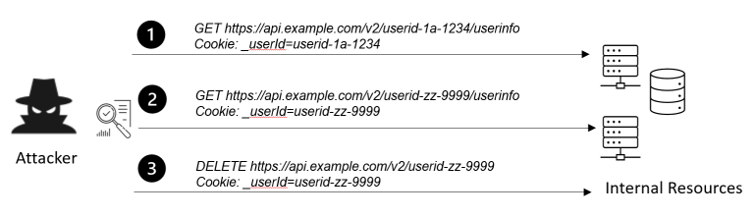
An API endpoint that retrieves user information based on a user ID may lack proper authorization checks. If an attacker modifies the user ID in their request, they could access another user’s data without permission.

API Testing for BOLA
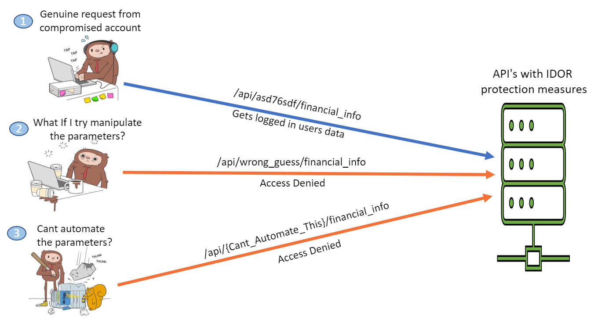
API testing is crucial to identify and mitigate BOLA vulnerabilities. The following steps outline the process:

Steps for Testing:
- Mapping API Endpoints: Identify all endpoints interacting with objects, such as user data, orders, or files.
- Object Identification: Understand how objects are referenced, such as through IDs or tokens.
- Manipulating Object References: Modify object identifiers in API requests to test for unauthorized access.
- Response Analysis: Examine responses to determine if unauthorized data or functionalities are exposed.

Tools for API Testing:
- Postman: For sending and modifying API requests.
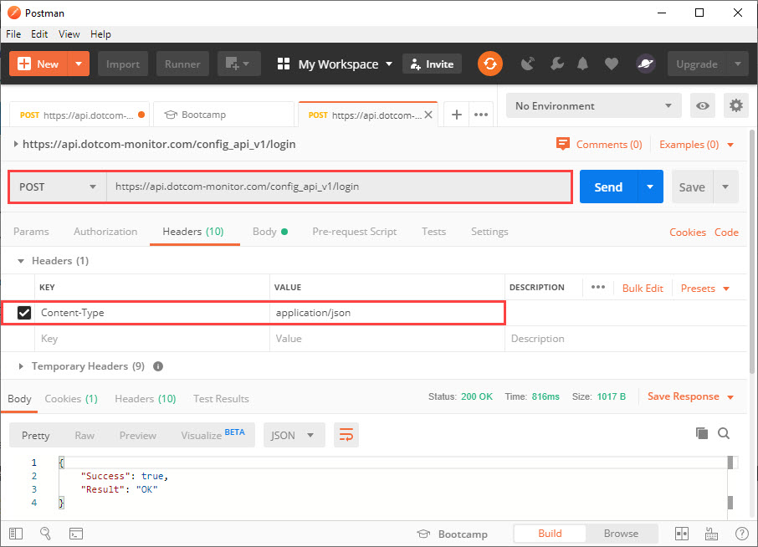
- Burp Suite: To intercept and manipulate API traffic.
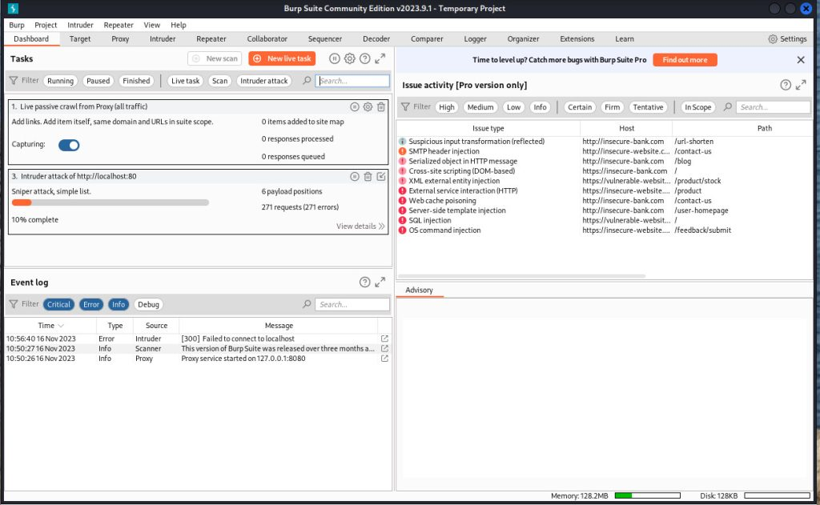
- OWASP ZAP: For automated vulnerability scanning of APIs.
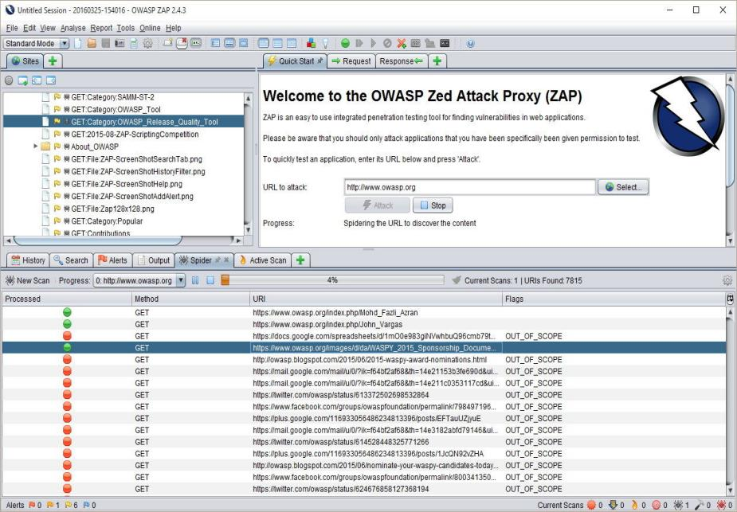

Impact and Issues of BOLA
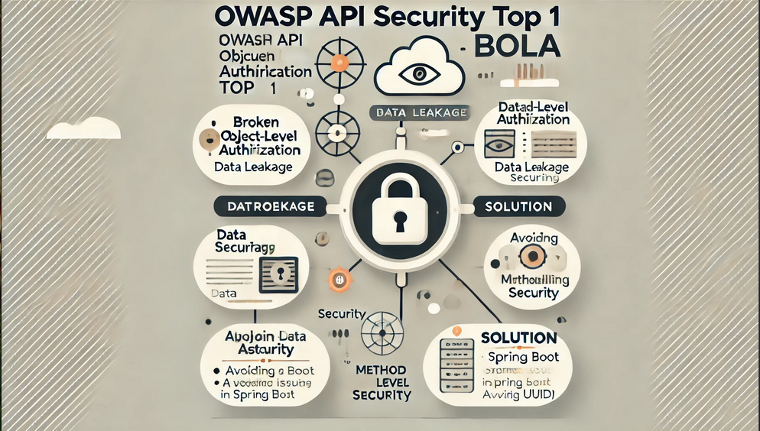
The consequences of BOLA can be severe, affecting both users and organizations. Common impacts include:

Impacts:
- Data Breaches: Exposure of sensitive information such as personal data, financial records, or health details.
- Account Takeover: Attackers can access and control user accounts, leading to potential misuse.
- Service Disruption: Unauthorized modifications to resources or configurations can disrupt operations.
- Regulatory Penalties: Non-compliance with data protection laws, such as GDPR or CCPA, resulting in hefty fines.

Common Issues:
- Improper Authorization Checks: Failing to validate user permissions for each object access.
- Predictable Object References: Using sequential or easily guessable IDs for objects.
- Lack of Logging and Monitoring: Difficulty in detecting and responding to unauthorized access.

Mitigation Strategies
To address BOLA vulnerabilities, organizations should implement the following measures:

Best Practices:
- Role-Based Access Control (RBAC): Enforce fine-grained access controls based on user roles.
- Server-Side Authorization: Perform authorization checks on the server for every request.
- Secure Object References: Use randomized, non-sequential identifiers like UUIDs or GUIDs.
- Comprehensive API Testing: Regularly test APIs for vulnerabilities using automated and manual methods.
- Audit Logs: Maintain detailed logs of API activities to detect and investigate unauthorized access attempts.

Conclusion
Broken Object Level Authorization (BOLA) is a pervasive and critical security issue, particularly in applications with extensive API integrations. Addressing BOLA requires robust authorization mechanisms, thorough testing, and adherence to security best practices. By prioritizing these measures, organizations can safeguard sensitive data and maintain user trust.

References
- OWASP API Security Top 10. (2025). OWASP.
- OWASP Mobile Security Testing Guide. (2025). OWASP.
- Postman API Testing Guide. (2025). Postman.
- Burp Suite Documentation. (2025). PortSwigger.
- Symantec Threat Report. (2024). Symantec.

